PELHAM, NH POLICE DEPARTMENT
RECRUITING FOR A FULL-TIME POLICE PROSECUTOR

The Town of Pelham Police Department, a nationally accredited law enforcement agency, has an opening for a full time, non-union, Police Prosecutor. The Police Prosecutor is responsible for the preparing and presentation of cases in District Court. He/she also works with the Office of the County Attorney to present cases to Grand Jury and prepare cases for Superior Court. The Police Prosecutor works under the general supervision of the Administrative Operations Commander. Salary is between $75,000-$82,000 depending on experience and qualifications. Benefits include Health & Dental Insurance, New Hampshire Retirement System, paid time off, short -term disability leave, 11 paid holidays and an assigned vehicle.

Position responsibilities:

- Coordinate the scheduling of cases for the department and review each case presented to him//her for possible errors or omissions.
- Review each case and assess any additional documents or information as needed.
- Must record all arraignment and trial dates as well as proper tracking of ALS hearings and subpoena all officers to attend.
- Maintain effective working relationships between the courts and the department and notify the Chief of Police of any unusual occurrences that may require attention.
- Advise Department Heads and other Town Officials on legal matters and perform related research when necessary.
- Ensure all department cases pursued through the court system are prosecutable and sound and assist with the preparation of affidavits and warrants, as needed. He/she shall review and file all case-related correspondence, motions and prepare the required responses.
- Must fulfill the duties relating to the preparation and prosecution of juvenile cases.

Qualifications:
Bachelor’s degree from an accredited college or university as well as a Juris Doctor Degree from an Accredited Law School. Must be licensed to practice law in the State of New Hampshire by the New Hampshire Bar Association. Possession of a valid driver’s license in the state of one’s residence. Must have thorough knowledge of police investigation methods, state laws, local ordinances, and police regulations with emphasis on the NH Criminal and Motor Vehicle codes. Thorough knowledge of the principles and practices of court prosecutions. Applications are available online at www.pelhampolice.com or at the Pelham Police Department. Interested candidates should submit an application, cover letter, and resume to:

Lieutenant Brian Barbato
bbarbato@pelhampolice.com
Pelham Police Department
14 Village Green
Pelham, NH 03076

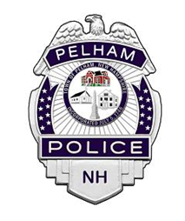
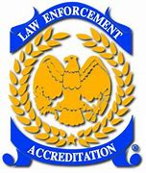
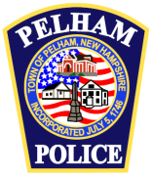
Applications will be accepted until the position is filled. The Town of Pelham is an equal opportunity employer.

